# What is the Sensorlist

## Introduction

The sensorlist is a validated description of the total FT system. Everything that is connected, whether it is a sensor, a serial connection, an engine etc. is represented in the sensorlist. The sensorlist is the start of where we build the topology, the network and all connected devices. Once imported, the sensorlist will be updated into a sensorlist_generated file that is pretty much automated. Missing files, wrong connections, etc. will be highlighted or even changed. New connections will be highlighted and fails will be highlighted as well.

If the sensorlist is kept well up to date all changes to the system can be made from within the sensorlist. It will be your ultimate tool to easily change your setup, change names or even add new sensors or complete devices. Also the sensorlist is a fine tool to troubleshoot the system. It makes it easy to find double connections, wrong terminations, strange values etc.

Learn how to work with the sensorlist and you’ve got half the job done.

## Excel

The sensorlist is composed in Microsoft Excel. Some knowledge on working with Excel is absolutely necessary. That part of training lies beyond the scope of this manual. We refer to books and courses for Microsoft excel to learn the basics.

It is enough to have basic knowledge because the sensorlist itself is merely a form you have to fill in with the appropriate data. The sensorlist exists of two parts (tabs) which are the “devicelist” and the “sensorlist”. The devicelist (see Figure 9‑1) contains all the devices where he system consists of and is namely an enumeration of the topology of the system. The sensorlist (see Figure 9‑2) on the other hand is a list of all the sensors attached to the system together with the necessary information for the connection.

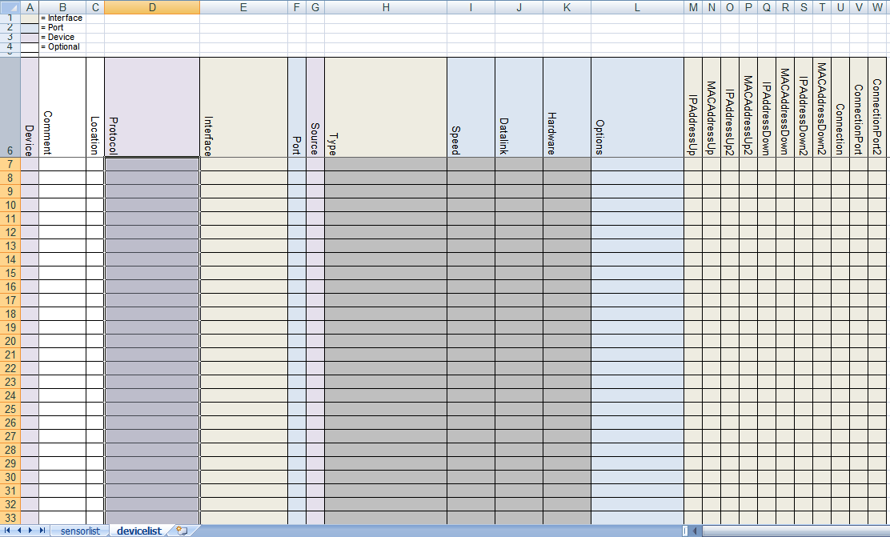

Figure 9‑1: devicelist

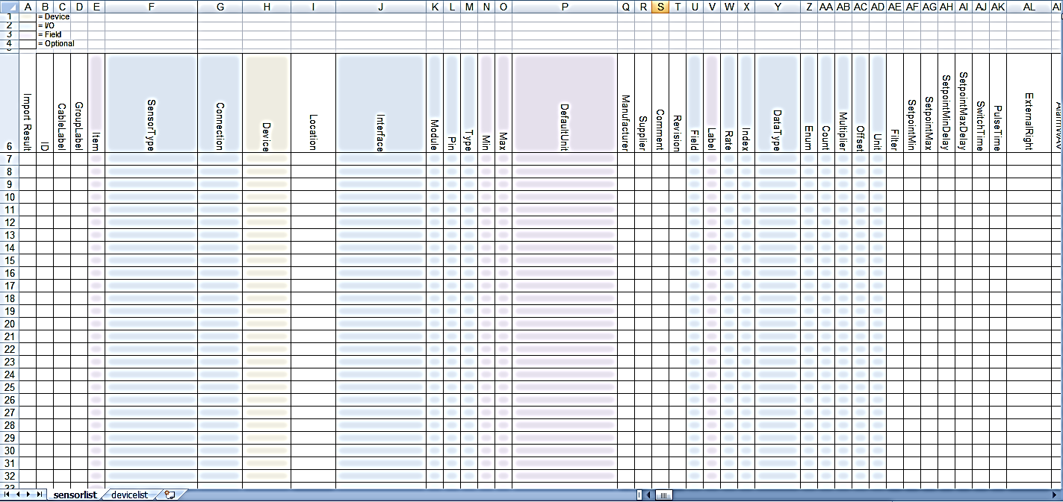

Figure 9‑2: Sensorlist

It goes unsaid that for filling in the sensorlist properly, you need to make sure that you have all the appropriate data form the shipyard available.

*:*

*Always ask Free Technics for the latest sensorlist. The sensorlist changes with upgrades in NavVision.*

## Saving and naming

For working with the sensorlist always make sure that you use the latest version of Microsoft Excel. At this moment this is Microsoft Excel 2010. Although it is also possible to work with an earlier version, we will use this version as an example in this manual.

While working on the sensorlist, make sure that you save your work regularly to prevent loss of data. Goto startbutton>save as>Excel workfolder (See Figure 9‑3).

Make sure you choose the right folder to save to and the right format (in this case .xlsx) and save the sensorlist with a distinctive name. When working on ship A you can use for example “sensorlist_shipA_v1.1.xlsx”. When renewing or changing the sensorlist you can add a new version number to distinguish the different versions (i.e. “sensorlist_shipA_v1.2”).

When working on the ship or on the original configuration, make sure that, together with the newest sensorlist, you take a backup of the complete NavVision folder.

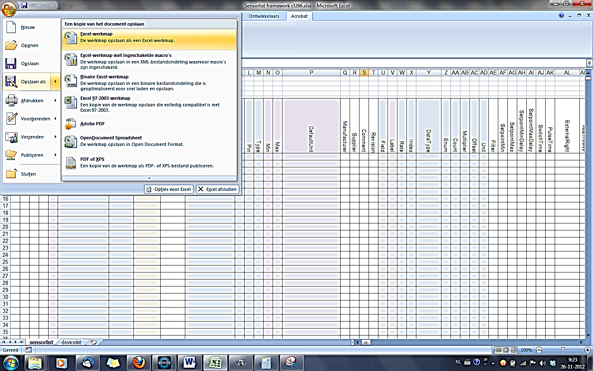

Figure 9‑3: Excel saving

## Saving as sensorlist for import

When saving the sensorlist to be used as import-file for NavVision you need to do two things:

After choosing “save as” you go to the drop-down menu for the file type and choose

“Excel 97-2003-workfolder (*.xls)” (see Figure 9‑4) while this is the supported format

for importing a sensorlist.

Save the sensorlist as “sensorlist.xls” no capitals.

Save this “sensorlist.xls” in the same folder as the sensorlist.xlsx you derived it from, so you can always check what has been changed and/or you can get back to previous versions.

For importing the sensorlist into NavVision we refer you to Chapter 12.

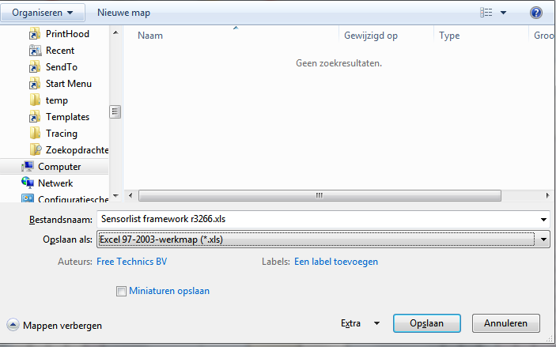

Figure 9‑4: saving as sensorlist.xls